Pom.xml
<?xml version="1.0" encoding="UTF-8"?>
<project xmlns="http://maven.apache.org/POM/4.0.0" xmlns:xsi="http://www.w3.org/2001/XMLSchema-instance"
xsi:schemaLocation="http://maven.apache.org/POM/4.0.0 http://maven.apache.org/xsd/maven-4.0.0.xsd">
<modelVersion>4.0.0</modelVersion>
<groupId>com.example</groupId>
<artifactId>configure</artifactId>
<version>1.0-SNAPSHOT</version>
<name>configure</name>
<!-- FIXME change it to the project's website -->
<url>http://www.example.com</url>
<properties>
<project.build.sourceEncoding>UTF-8</project.build.sourceEncoding>
<maven.compiler.source>17</maven.compiler.source>
<maven.compiler.target>17</maven.compiler.target>
</properties>
<dependencies>
<!-- Spring Context -->
<dependency>
<groupId>org.springframework</groupId>
<artifactId>spring-context</artifactId>
<version>5.3.39</version>
</dependency>
<!-- Spring AOP -->
<dependency>
<groupId>org.springframework</groupId>
<artifactId>spring-aop</artifactId>
<version>5.3.39</version>
</dependency>
<!-- Spring Web MVC -->
<dependency>
<groupId>org.springframework</groupId>
<artifactId>spring-webmvc</artifactId>
<version>5.3.39</version>
</dependency>
</dependencies>
<build>
<pluginManagement><!-- lock down plugins versions to avoid using Maven defaults (may be moved to parent pom) -->
<plugins>
<!-- clean lifecycle, see https://maven.apache.org/ref/current/maven-core/lifecycles.html#clean_Lifecycle -->
<plugin>
<groupId>org.apache.maven.plugins</groupId>
<artifactId>maven-compiler-plugin</artifactId>
<version>3.13.0</version>
<configuration>
<source>1.8</source>
<target>1.8</target>
</configuration>
</plugin>
<plugin>
<artifactId>maven-clean-plugin</artifactId>
<version>3.1.0</version>
</plugin>
<!-- default lifecycle, jar packaging: see https://maven.apache.org/ref/current/maven-core/default-bindings.html#Plugin_bindings_for_jar_packaging -->
<plugin>
<artifactId>maven-resources-plugin</artifactId>
<version>3.0.2</version>
</plugin>
<plugin>
<artifactId>maven-compiler-plugin</artifactId>
<version>3.8.0</version>
</plugin>
<plugin>
<artifactId>maven-surefire-plugin</artifactId>
<version>2.22.1</version>
</plugin>
<plugin>
<artifactId>maven-jar-plugin</artifactId>
<version>3.0.2</version>
</plugin>
<plugin>
<artifactId>maven-install-plugin</artifactId>
<version>2.5.2</version>
</plugin>
<plugin>
<artifactId>maven-deploy-plugin</artifactId>
<version>2.8.2</version>
</plugin>
<!-- site lifecycle, see https://maven.apache.org/ref/current/maven-core/lifecycles.html#site_Lifecycle -->
<plugin>
<artifactId>maven-site-plugin</artifactId>
<version>3.7.1</version>
</plugin>
<plugin>
<artifactId>maven-project-info-reports-plugin</artifactId>
<version>3.0.0</version>
</plugin>
</plugins>
</pluginManagement>
</build>
</project>
Output:
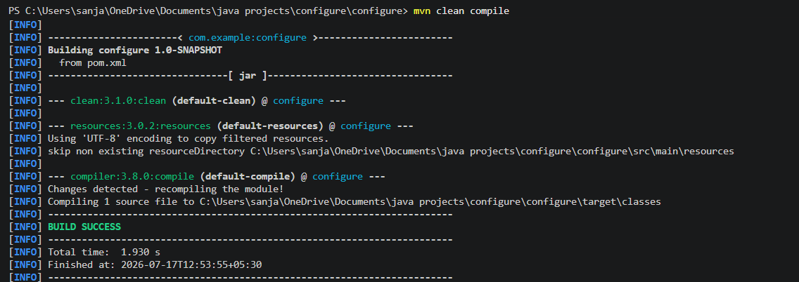

Images:
